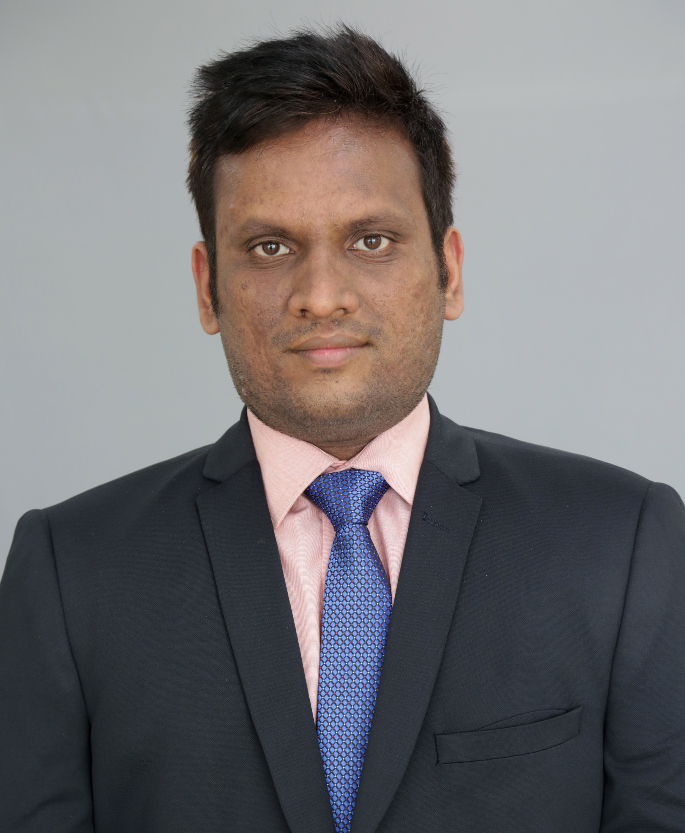

**Phanikrishna Velicheti**

401,G-block,Brigade Metropolis,Garudachar Palya,Mahadevapura,Bengaluru,Karnataka-560048

PHONE:+91 9959676104

Mail:velicheti2phani@gmail.com

**Professional Summary**

* Pursing Post Graduation diploma in Data science
* Having 2 years of experience in Software Industry.
* Worked as an Application Developer in Tata Consultancy Services, Kolkata.
* Participated in the International Global Datathon(2019) ,”Hack The News ”, on Text Analytics
* Participated in the Kaggle competitons –Titatinc Machine Learning from Disaster

**Professional Experience**

* **2 Years** of IT experience in Data ware housing.
* Good Knowledge in Machine Learning,Data Mining,Statistics
* Hands on experience with Agile Development Model and Waterfall Model.
* Having good knowledge in programming in various languages, communication and interpersonal skills, active team worker and full of enterprise initiatives.

**Technical Skills Set**

* **Platforms**: Google Cloud Platform, Unix, Windows.
* **Languages** : Python,R, SQL
* **Tools**:Tableau
* **Database** : Oracle database 11g, MySQl
* **Others:** Machine Learning ,statistics,Data Mining
* **Domain:** Retail

**Academic Projects:**

* **Project** : Breast Cancer Prediction

**Technolgy Used**: Python(Machine Learning Algorithms)

**Project Description**: Built a model with good accuracy score , whether a person is effected with cancer or not

* **Project** : Dashboard creation -IPL dataset(2008-2016)

**Technolgy Used**: Tableau

**Project Description**: Built a dashboard on IPL data set with he help of KPI boxes ,bar graph

**Work History**

**Tata Consultancy Services**

**(Oct2016– Oct2018)**

**Project** : Morrisons(Business IntelligenceDepartment)

**Technology Used**: Google Cloud Platform, BigQuery, Dataflow, Pub/Sub,

**Project Description**: Morrison’s is a leading chain of supermarkets in the United Kingdom and also it is trading grocery items via a web shop through Ocado M.Com grocery channel since 2014.

**Roles and Responsibilities:**

* Requirement analysis
* Application design and maintaining design specification and test case specification as per the new changes.
* Development and coding for new functionality incorporation.
* Analysis of codes and jobs in AWS and Google Cloud Platform to understand the new application.

**Internship:**

**Kopenz Private Limited, Bombay(Inayo)**

**(Jan2016– June2016)**

**Technology Used**: Python,Django

**Project Description**: Distribution of medicines through an app within 90 mins throughout the Bombay city

**Roles and Responsibilities:**

* Worked as python backend developer for structuring the database using mysql .

**Education**

* **Post-Graduation :** Pursing Post Graduation diploma in data science form Manipal ProLearn
* **Post-Graduation**: Masters of science in IT with CGPA 8.3 from Jawaharlal Nehru Technological University Kakinada(JNTUK)
* **Graduation** : B.Tech with 68% from Jawaharlal Nehru Technological University Hyderabad (JNTUH)
* **XII th:** Higher Secondary Education – Andra Pradesh(12th score 83.5 %).
* **X th**: Secondary Education - Andra Pradesh (10th score 76%).